EXPERIMENT- 39
Vehicle Detection in a Video Frame using OpenCV
Aim
To write a Python code to detect moving vehicles from a video using OpenCV background subtraction technique.
Input Video
(Upload vehicle traffic video)
Code
from google.colab import files
import cv2
from google.colab.patches import cv2_imshow
uploaded = files.upload()
video_path = list(uploaded.keys())[0]
cap = cv2.VideoCapture(video_path)
fgbg = cv2.createBackgroundSubtractorMOG2()
while True:
ret, frame = cap.read()
if not ret:
break
fgmask = fgbg.apply(frame)
contours,_ = cv2.findContours(
fgmask,
cv2.RETR_EXTERNAL,
cv2.CHAIN_APPROX_SIMPLE
)
for contour in contours:
if cv2.contourArea(contour) > 500:
x,y,w,h = cv2.boundingRect(contour)
cv2.rectangle(frame,(x,y),(x+w,y+h),(0,255,0),2)
cv2_imshow(frame)
if cv2.waitKey(30) & 0xFF == ord('q'):
break
cap.release()
cv2.destroyAllWindows()
Output Video
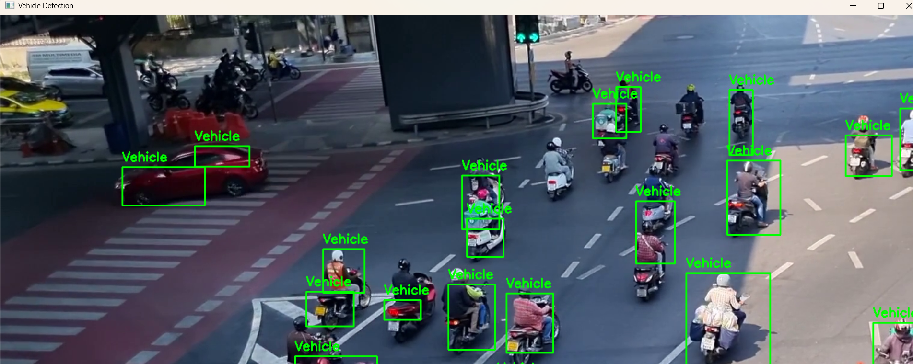Result
Thus, the moving vehicles were successfully detected using OpenCV background subtraction.

